**DIY JET Cookbook**

**Create a form**

<http://www.oracle.com/webfolder/technetwork/jet/jetCookbook.html>

To familiarize yourself with the JET cookbook you are going to create a form with input fields and a button. For this you will use the “Forms” and “Controls” section of the Cookbook.

Checklist when using a component from the cookbook:

* Only use HTML from component (don’t copy all the code)
* Only use the JavaScript needed for the component
* Include component in define-block (watch out for doubling)

Make this form:

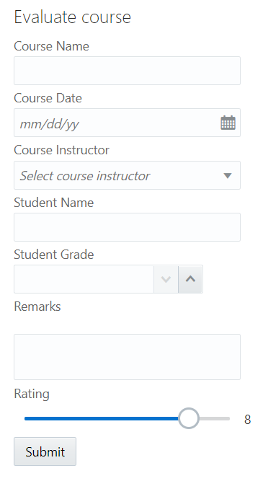 The following components are used:

* HTML header
* Labels
* Input Text
* Input Date
* Select
* Input Number
* Text Area
* Slider
* Button

A few things to know when creating the form:

* Use a placeholder for the course instructor select.
* The rating is shown by using a readonly Input Text where an observable is reused

**Additional**

* Add other Cookbook Forms or Controls components to your page
* Add required fields and validation to your form

**Result: Project FormSetUp on Github**

**DIY JSON SERVER & POST**

**Submit information in the form**

**Install JSON-server**

<https://medium.com/codingthesmartway-com-blog/create-a-rest-api-with-json-server-36da8680136d>

The JSON-server will function as a mock server to store our data.

* Do an npm install of the JSON-server in your project
* Create a JSON-file in the top folder of your project: “evaluations.json”
* Add this JSON-object to your JSON-file: { “evaluations”: [] }
* In a second terminal run the JSON-server: json-server --watch evaluations.json
* Go to the url where the JSON-server is running. You will see an empty array.

**Requests**

<https://www.getpostman.com/docs/v6/postman/sending_api_requests/requests>

* Copy the contents from submitForm.json (in the Github project) to your evaluations.json so you have some content.
* Do a GET-request to see the evaluations
* Create a POST-request in Postman
  + Add header Content-Type: application/json
  + Create body, you can copy an object from the GET-request, change the data and delete the id-row.
* When the POST-request works, you will see the newly added evaluation in your JSON-file and when you do a new GET-request.

This POST-request is what you want to happen when the submit-button is pressed in your form. The next step is to implement this in the application.

**Add POST-request to form**

* The button you have created in the previous exercise only opens an alert. Delete the alert and implement the POST-request.
  + Use the jQuery Ajax request: <http://api.jquery.com/jquery.ajax/>
  + Use: type, url, data and contentType
  + For data: Recreate the body for the request with the observables
  + To test: Check in browser console -> Network if request comes back with status 201
* You will notice that the form doesn’t clear after pressing submit. You can use the .done() function to clear the observables. <https://api.jquery.com/deferred.done/>

**Additional**

* If you added any other components to your form add them to the POST-request body if needed
* Add a thank you message after the submit is done that disappears after a few seconds.

**Result: Project FormSubmit on Github**

**DIY Collection & Table**

**Create Table**

**Common Model**

<http://www.oracle.com/webfolder/technetwork/jet/jetCookbook.html?component=table&demo=ojCollectionTable>

<http://www.oracle.com/webfolder/technetwork/jet/jetCookbook.html?component=crud&demo=table>

The table-component needs to get data from the JSON-server in order to show it. JET has defined an easy way to do this with the Common Model Framework. In this framework you define a Model that represents a single record in the Collection. A table can use the collection to do CRUD-actions on the data.

In the table we want to show all the data of all the evaluations. Use a different page in your application for this table.

* Define the Model for an evaluation.
* Parse data for easier use.
* Define the collection that uses the Model to fetch data.

**Table**

* Add the Table component from the cookbook (remember the Cookbook Checklist).
* Define the columns.
* Define the data source.
* Once you have your table up and running you might notice that a new entry through your form isn’t shown immediately in the table.
* This is where the handleActivated function comes in. The handleActivated function is one of the functions that JET generates automatically in the navbar template (you will see it when opening a newly generated JS-file). It can be used to get data before the page is shown.
* Assign your data source inside the handleActivated. Your table will refresh.

**Additional:**

* Use the cookbook and the JS Doc of the table component to further configure your table.
  + Make the columns sortable / orderable / resizable
  + Add a Custom Cell Template for the rating (Visualizations – Gauge – Rating Gauge)
* Keep the cell empty when remarks are shown as “undefined”.
* Use the same collection for a different representation of data in a different component (List View or Data Grid)

**Result: Project FormTable on Github**